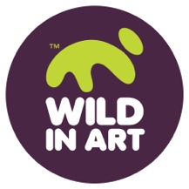
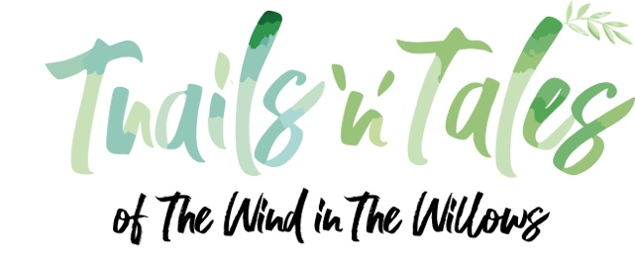

Design Competition Entry Form

Contact Information

First Name:

Surname:

Address:

Postcode:

Telephone:

Email:

Age Category (please tick):

 | Early Explorers (Ages 4-6) |  | Emerging Artists (Ages 12-15)
 | Young Creators (Ages 7-11) |  | Open Category (Ages 16+)

What three challenges or actions will you take (or encourage others to take) to protect wildlife and the environment?

1:

2.

3.

Tell us about your design

We’d love to know:

- What story or message does it share?
- What challenges are you highlighting?
- How do you hope people will feel or respond when they see your design?

(Maximum 150 words)

By completing and returning this submission you agree to the terms and conditions of entry on the following page and as set out at wildinart.co.uk/windinthewillows and the use of your design(s), including your fist name being included on the Wild in Art website.

Signed:

Print name:

Name of Parent of Guardian:

Signature of Parent of Guardian:

Date:

Please send us your completed entries by email to windinthewillows@wildinart.co.uk with by 31 August 2026 at midnight.

Be sure to include your Design and your Entry Form as attachments to your email.
Wind in the Willows Design Competition Terms and Conditions

1. This competition will run from 20 May – 31 August 2026. The closing date of this competition is 31 August 2026 at midnight.

2. The competition age categories are: Early Explorers (Ages 4-6), Young Creators (Ages 7-11), Emerging Artists (Ages 12-15), Open Category (Age 16+). Only one entry per person will be accepted.

3. Entry is open to residents of the UK except employees (and their families) of Wild in Art, its agents, the suppliers of prizes and any other companies associated with the Wind in the Willows trails or this prize draw.

4. Entries must be created on the Wind in the Willows templates provided at wildnart.co.uk/windinthewillows or from the Wind in the Willows Activity Book

5. The winning designs for each age category will be selected by the judging panel. The winners will be contacted by email and announced on the Wild in Art website

6. Reasonable efforts will be made to contact the winners. Failure to respond and/or failure to meet the eligibility requirements may result in forfeiture of the prize. If they cannot be contactable, or are unable comply with these terms and conditions, Wild in Art reserves the right to choose an alternative winning design.

7. The prize package (per age category winner) is a full set of four Paint Your Own Wind in the Willows figurines, an illustrated edition of The Wind in the Willows and a Book Token. Winning and highly commended designs will be featured in our online gallery. There is no cash alternative and the prize is non-transferable.

8. By entering the competition you agree that your design (along with your first name) may appear on the Wild in Art website.

9. Winners agree to co-operate with any other reasonable requests by Wild in Art relating to any post-winning publicity.

10. Wild in Art Limited is the promoter of this competition. Wild in Art will use information supplied on the entry form in relation to this competition. Personal data will be processed in accordance with Wild in Art’s Privacy Notice available at https://wildinart.co.uk/privacy-notice

11. The decision of the judges is final based on the criteria set out in the competition and no correspondence will be entered into over this decision.

